Numbers in Assignment Names
 | When you look at the assignment names, you'll notice they include several numbers and symbols. Here's what they mean: | Example
 |  | ❻OMAM🐁🧍 👑④Culminating Writing Project-Planning-Body ¶¶ 7-9
 | The first number (before the assignment name) shows the week of the quarter when the assignment was given. | In ❻OMAM🐁🧍, the "6" means it was assigned in Week 6.
 | The second number (inside the circle, like ④) comes right before the words "Culminating Writing Project" and shows which chunk of the culminating writing project this assignment covers. | In 👑④Culminating Writing Project, the "4" means it's the fourth chunk.
 | The pilcrow symbols (¶¶) followed by numbers (like ¶¶ 7-9) tell you which body paragraphs are part of this assignment. | In Body ¶¶ 7-9, this assignment covers paragraphs 7 through 9.
 | In these instructions about the sequence of copying and pasting, the number referenced in regard to the Culminating Writing Project is the number in the circle before the words Culminating Writing Project (e.g., the ④ in 👑④Culminating Writing Project).

Copying Cells
 | Although in these instructions, for the purpose of clarification, I am including an image of the paragraphs you will select that includes the header information (such as “Introductory ¶,” “Body ¶¶ 7-9:Third Character,” and so on) and side labels (such as “⛛,” “Topic Sentence,” “C,” “E,” and so on), when you are copying and pasting, you should only select the cells that contain the scaffolded text itself and your writing, without including the header or side labels. | The instructions will look like this: | But only copy and paste this:
 |  | 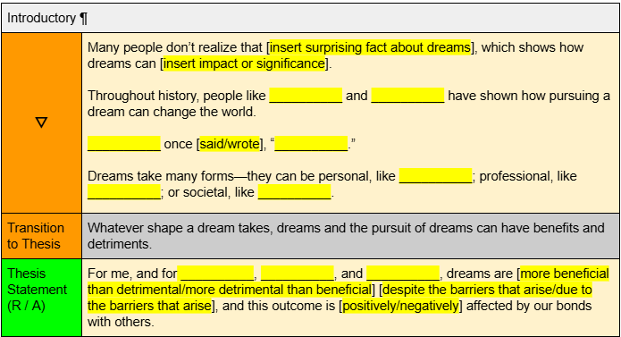 | 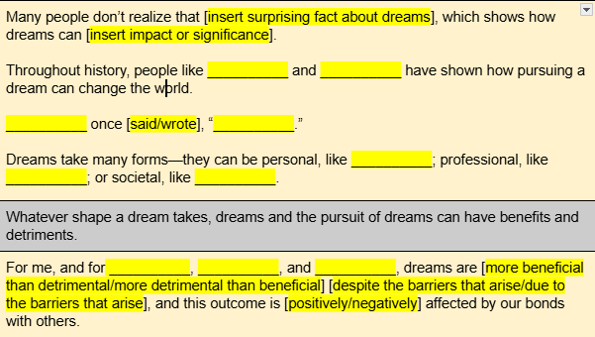

Instructions for the Sequence of Copying and Pasting
Step | Instructions | Assignment Name | Visual Representation
1 | Verify the Correctness of Your Thesis Statement
 | Open ⑦ | ❽OMAM🐁🧍 👑⑦Culminating Writing Project-Planning-Introductory ¶ & Conclusory ¶ | 
 | Also open ① | ❹OMAM🐁🧍 👑①♦️Culminating Writing Project | Thesis Statement | 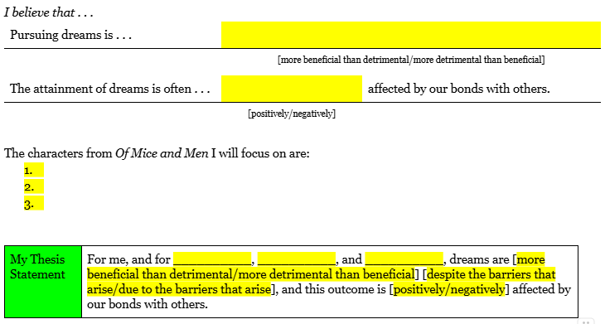
 | Look at the thesis statement from ⑦ . . . | ❽OMAM🐁🧍 👑⑦Culminating Writing Project-Planning-Introductory ¶ & Conclusory ¶ | 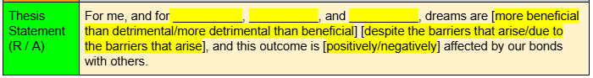
 | . . . and compare it to the thesis statement in ①. | ❹OMAM🐁🧍 👑①♦️Culminating Writing Project | Thesis Statement | 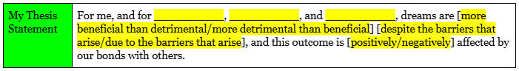
1.a. | If the thesis statement matches:
 | Copy your entire introduction from ⑦ into the MLA template. | ❽OMAM🐁🧍 👑⑦Culminating Writing Project-Planning-Introductory ¶ & Conclusory ¶ | 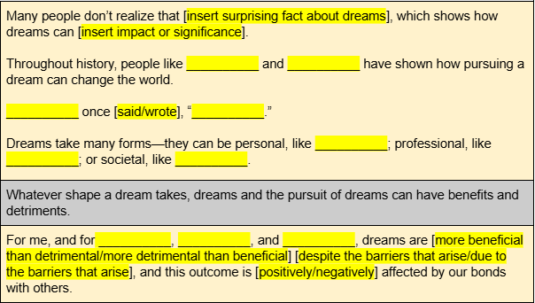
1.b. | If the thesis statement does NOT match or is incorrect in ⑦:
 | Copy the “⛛” (hook) and “transition to thesis” from ⑦ into the MLA template. | ❽OMAM🐁🧍 👑⑦Culminating Writing Project-Planning-Introductory ¶ & Conclusory ¶ | 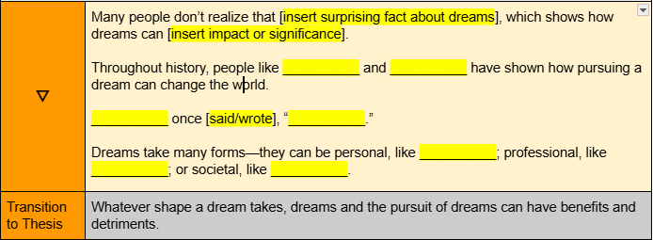
 | Copy the correct thesis statement from ① into the MLA template. | ❹OMAM🐁🧍 👑①♦️Culminating Writing Project | Thesis Statement | 
 | Together, these pieces constitute a single (introductory) paragraph. |  |   
In the MLA template, the introductory paragraph should include:
- The hook
- The transition to thesis
- The correct thesis statement
2 | Copy body paragraphs 1-3 (George) from ② into the MLA template. | ❹OMAM🐁🧍 👑②♦️Culminating Writing Project-Planning-Body ¶¶ 1-3 | 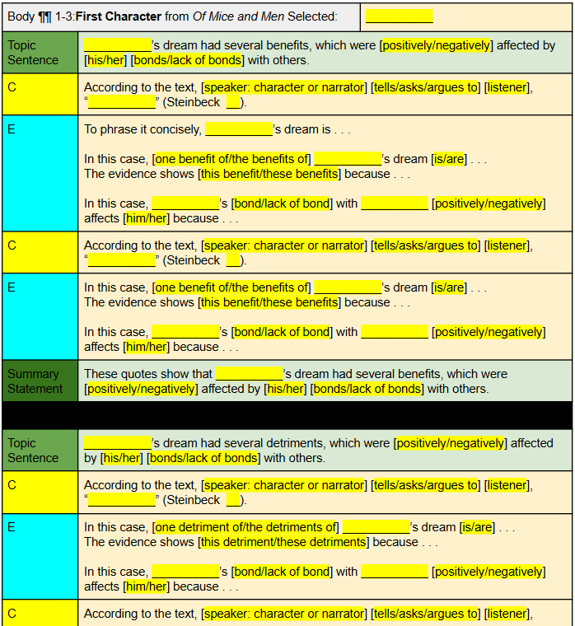  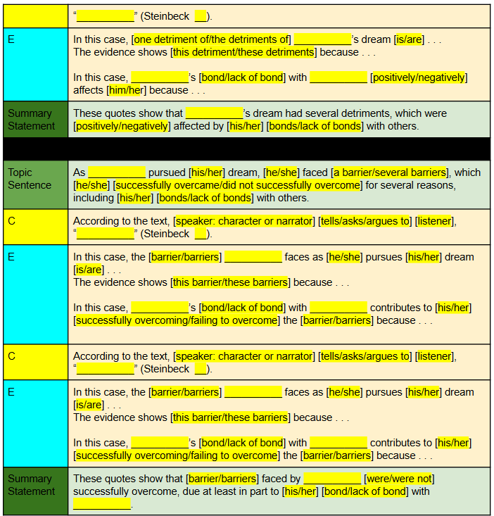
3 | Copy body paragraphs 4-6 (Lennie) from ③ into the MLA template. | ❺OMAM🐁🧍 👑③♦️Culminating Writing Project-Planning-Body ¶¶ 4-6 | 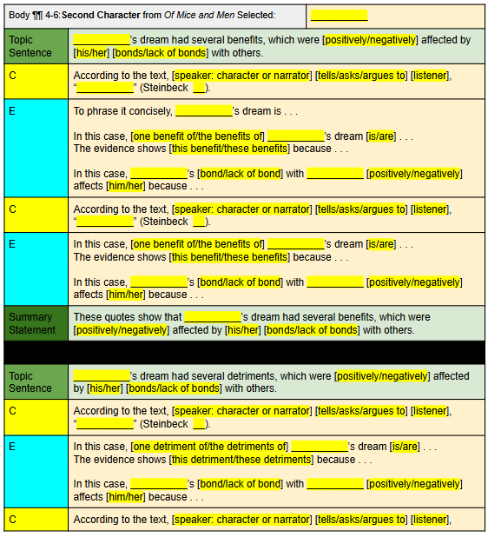  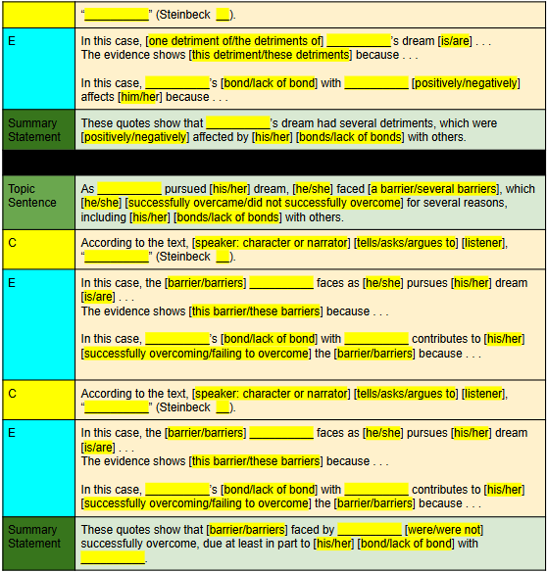
4 | Copy body paragraphs 7-9 (Candy or Curley’s Wife) from ④ into the MLA template. | ❻OMAM🐁🧍 👑④♦️Culminating Writing Project-Planning-Body ¶¶ 7-9 | 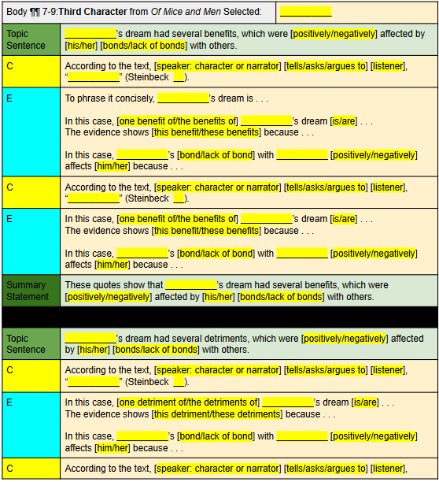  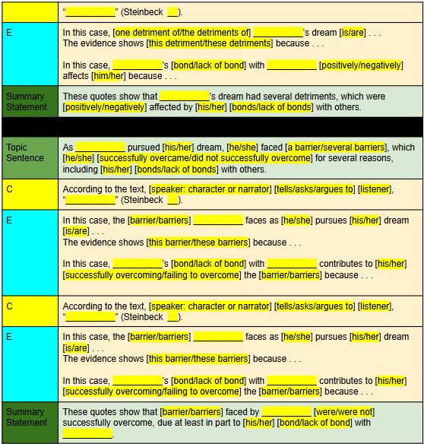
5 |  | ❻OMAM🐁🧍 👑⑤♦️Culminating Writing Project-Planning-Body ¶ 10 (Counterargument: Character Other Than George) | 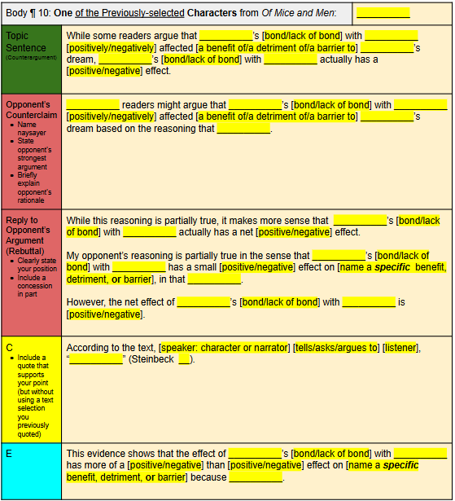
6 |  | ❻OMAM🐁🧍 👑⑥♦️Culminating Writing Project-Planning-Body ¶¶ 11-13 (Personal Connection and Evidence) | 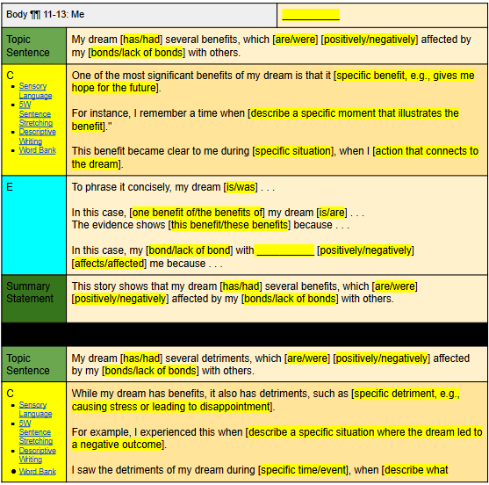  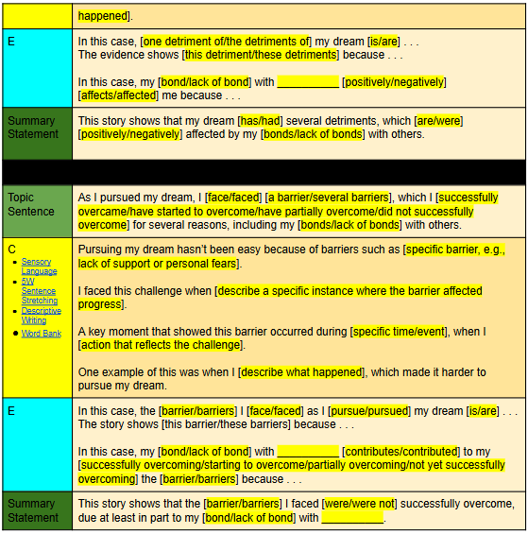
7 | Copy your entire conclusory paragraph from ⑦ into the MLA template. | Introductory and Conclusory Paragraphs: ❽OMAM🐁🧍 👑⑦♦️Culminating Writing Project-Planning-Introductory ¶ & Conclusory ¶ | 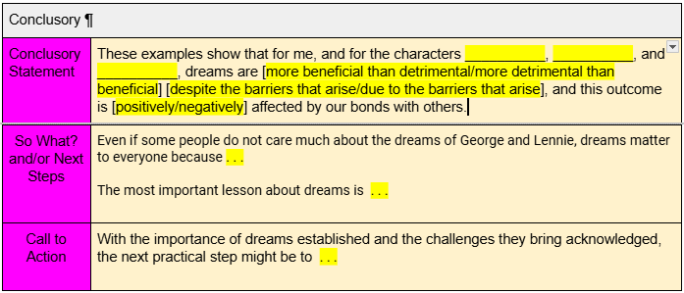

Find & Replace Tricks
1. | Brackets
 | Use the Find and Replace tool (CTRL+H or access through “Edit”):
 | In the Find box, type [ (or ]) (search for one type of bracket at a time). | 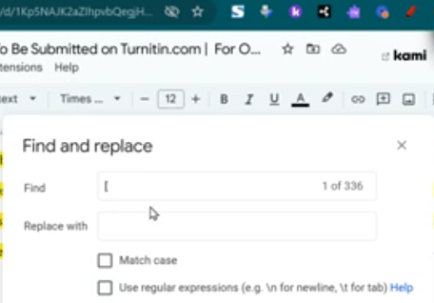
 | In the Replace box, make sure the box is empty.
 | Click Replace All.
2. | Ellipses
 | Use the Find and Replace tool (CTRL+H or access through “Edit”):
 | In the Find box, type (. . . ) without the parentheses. | 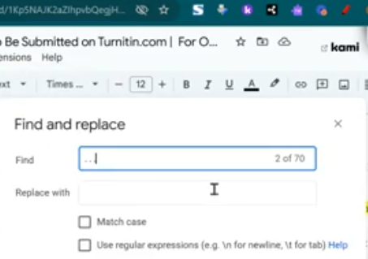
 | In the Replace box, make sure the box is empty.
 | Click Replace All.
3. | Extra Spaces
 | In the Find box, type two spaces ( ) without the parentheses. | 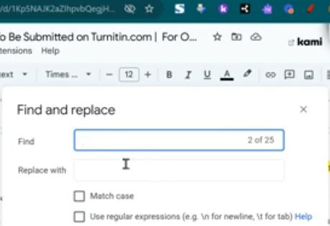
 | In the Replace box, type one space ( ) without the parentheses.
 | Click Replace All.

Additional Tips
1 | Using Placeholders When Copying  If you decide to copy a section (such as a body paragraph or other pieces) into your larger MLA document before you have completely finished all of the chunked assignments, then follow these steps to ensure you can easily insert the paragraphs in the correct location later:  - Instead of copying and pasting the actual paragraph right away, type three dashes --- (or any other simple symbol, ) where the paragraph or section should go. This symbol will act as a placeholder so you can easily locate the spot where the paragraph should be placed later.  - Continue working on your other sections. When you have finished all parts of the assignment, you can return to the placeholder spots and replace the --- with the actual paragraph text.  This method will help ensure that you don’t accidentally place text in the wrong location while working on different sections at various stages.
2 | Turning Off and On the "Show Print Layout" Feature  To make copying and pasting easier in Google Docs, follow these steps to turn off the Show Print Layout feature while you work:  - Go to the View menu at the top of the screen  - Click Show Print Layout to uncheck it. When it's turned off, you'll notice that the page breaks disappear, and the document will look more like a continuous scroll.  - With Show Print Layout turned off, copying and pasting will be smoother and less confusing because you won’t see page breaks or extra formatting that might interfere with your workflow.  - Once you’ve finished copying and pasting, go back to the View menu.  - Click Show Print Layout to check it again. This will bring back the page breaks, and your document will appear in its normal format, which is helpful for final review and formatting.  This adjustment helps avoid confusion during the copying and pasting process, but don’t forget to turn it back on for proper formatting before submitting your work.

